Thermometer
# Source: AI Source: Provided by: [Data Path: Persons Table -> ID Column: 1, Name_En Column: Motasem Essam] -> From: [ChatGPT] on [7/17/2026]
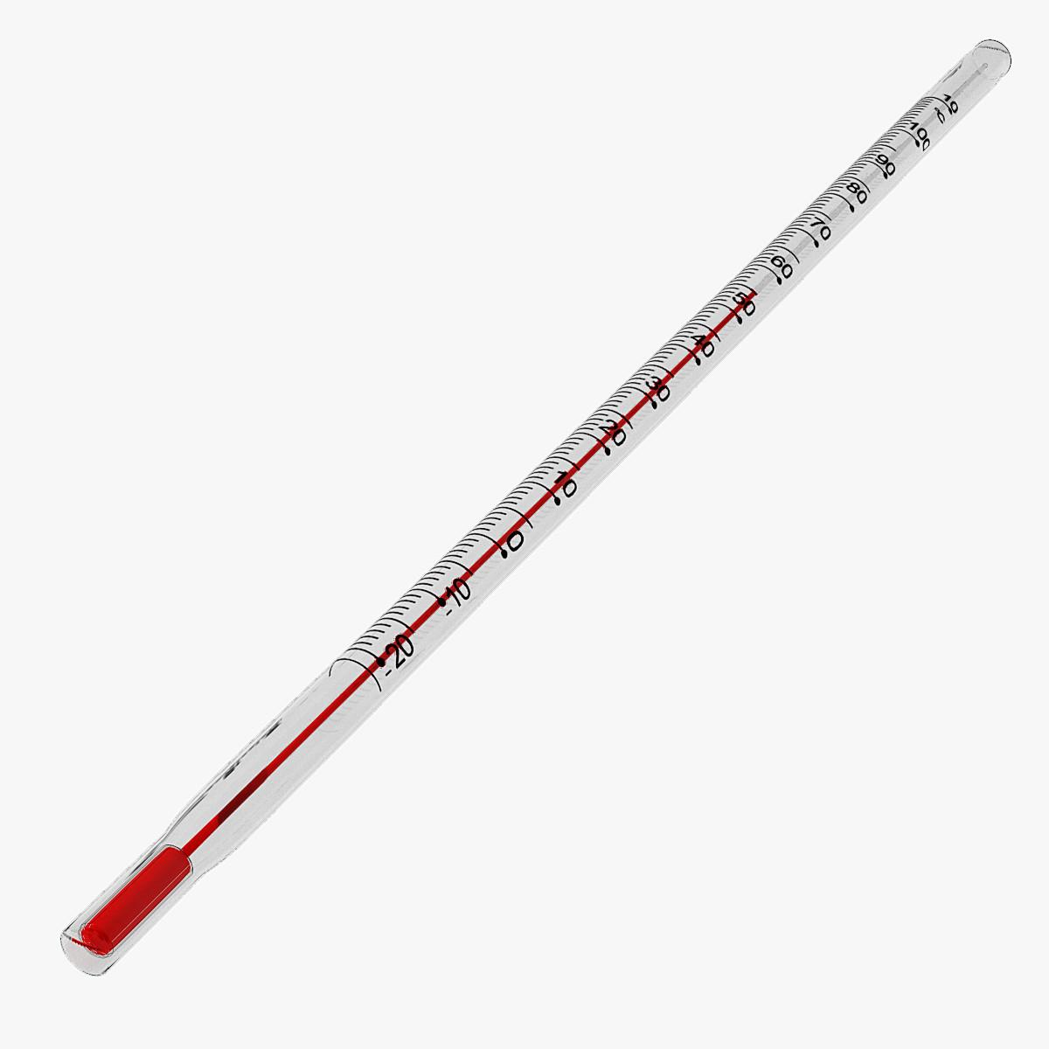
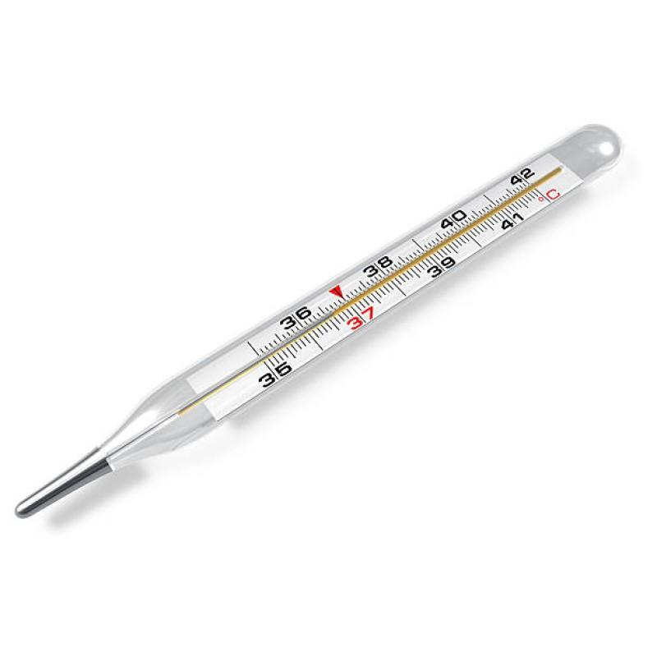
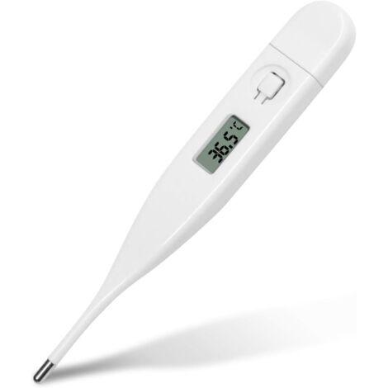
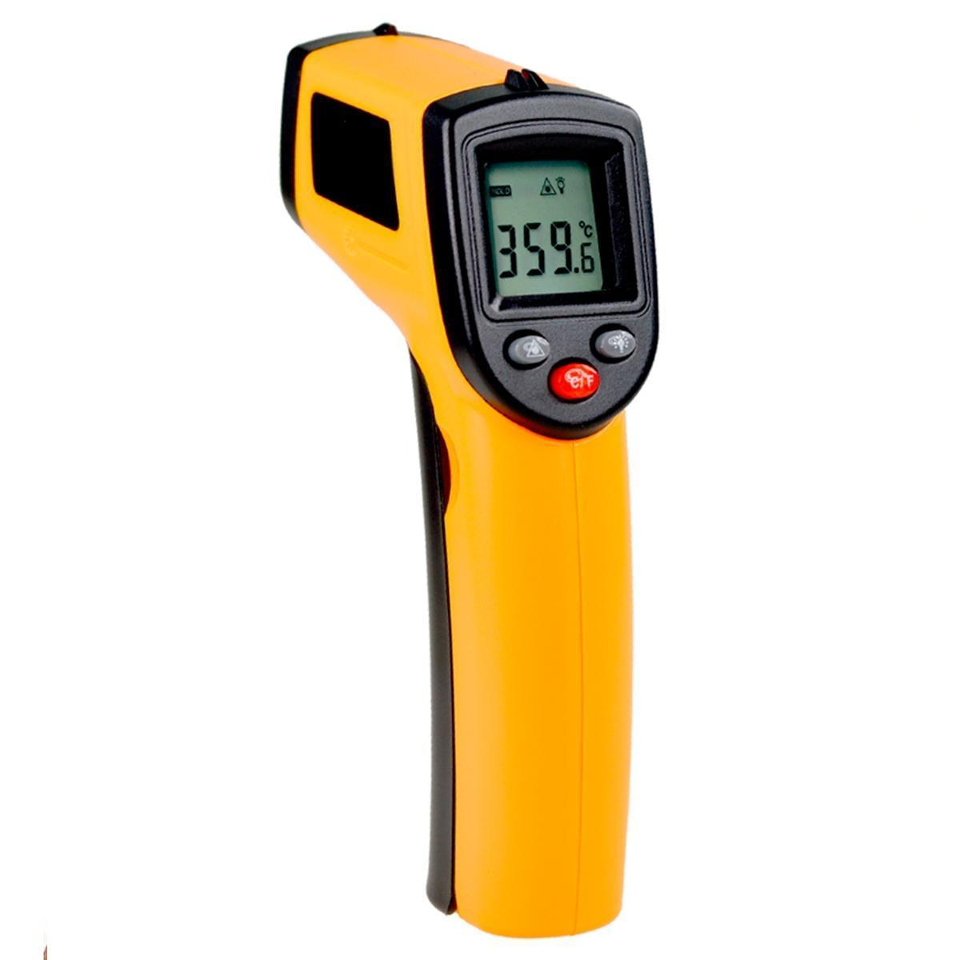
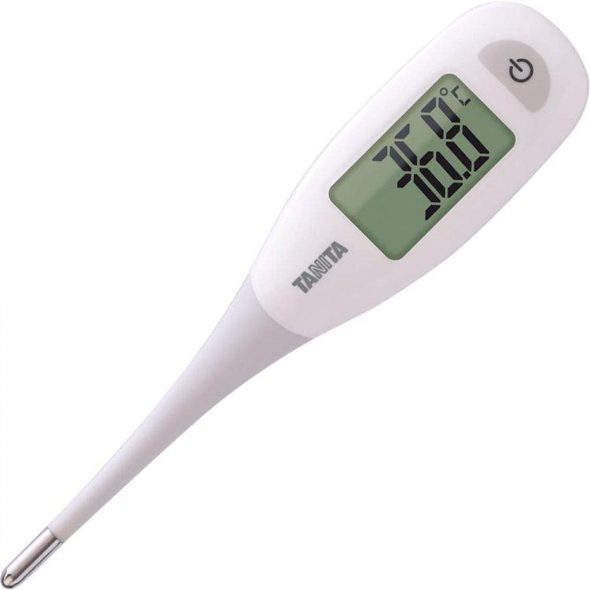
A Thermometer is a measuring instrument used to determine the temperature of solids, liquids, gases, or the human body. It works by detecting changes in a physical property—such as the expansion of a liquid or changes in electrical resistance—and converting them into a temperature reading.
Thermometers are widely used in medicine, laboratories, industry, meteorology, food processing, HVAC, and scientific research.

Definition
# Source: AI Source: Provided by: [Data Path: Persons Table -> ID Column: 1, Name_En Column: Motasem Essam] -> From: [ChatGPT] on [7/17/2026]
A Thermometer is an instrument that measures temperature and displays it using a calibrated scale.

Purpose
# Source: AI Source: Provided by: [Data Path: Persons Table -> ID Column: 1, Name_En Column: Motasem Essam] -> From: [ChatGPT] on [7/17/2026]
A thermometer is used to:
- Measure body temperature.
- Measure air temperature.
- Measure liquid temperature.
- Measure surface temperature.
- Monitor industrial processes.
- Control laboratory experiments.

Principle of Operation
# Source: AI Source: Provided by: [Data Path: Persons Table -> ID Column: 1, Name_En Column: Motasem Essam] -> From: [ChatGPT] on [7/17/2026]
Thermometers measure temperature by sensing changes in physical properties.
Common operating principles include:
- Thermal expansion of liquids
- Electrical resistance changes
- Thermoelectric voltage
- Infrared radiation detection

Main Components
# Source: AI Source: Provided by: [Data Path: Persons Table -> ID Column: 1, Name_En Column: Motasem Essam] -> From: [ChatGPT] on [7/17/2026]
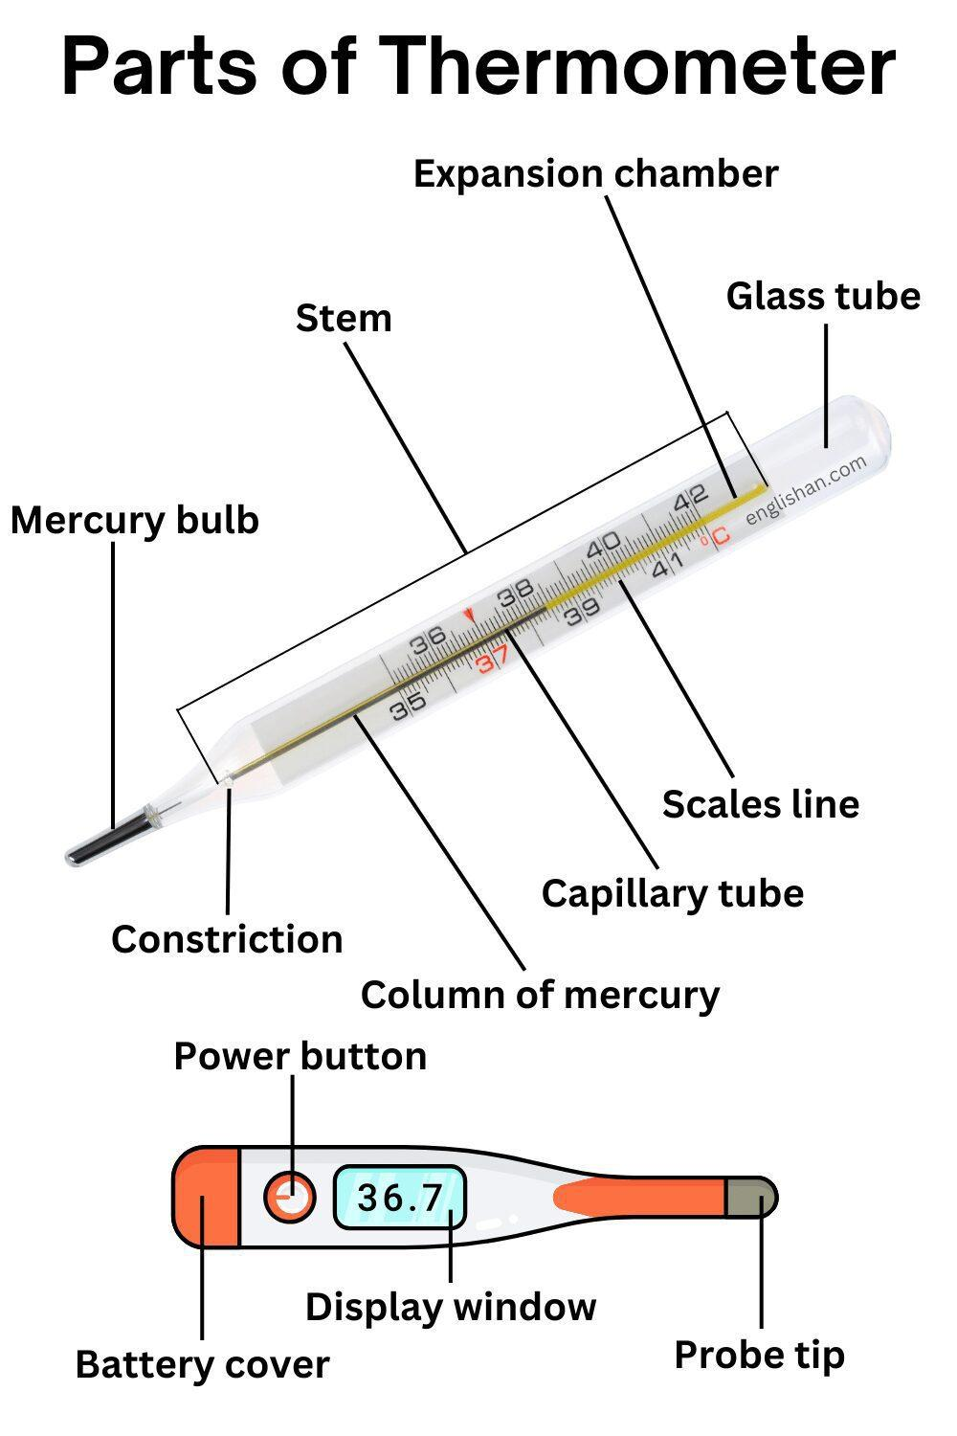
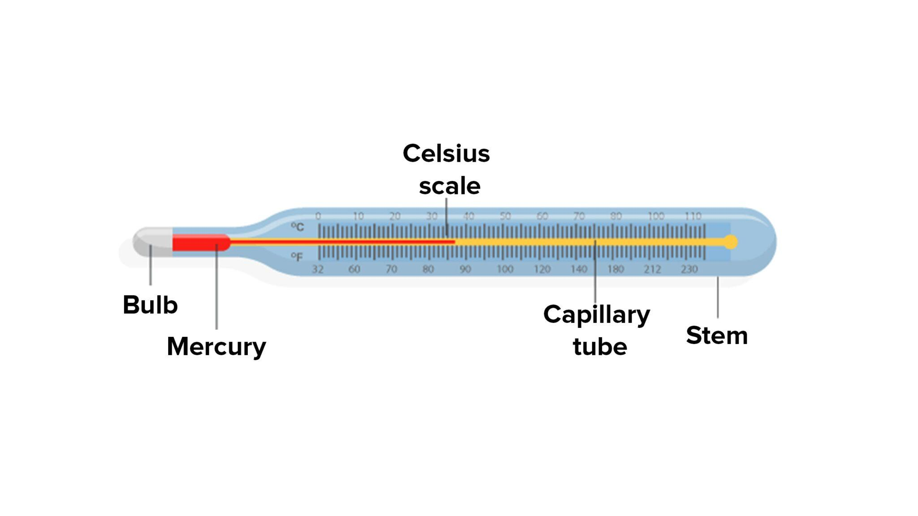
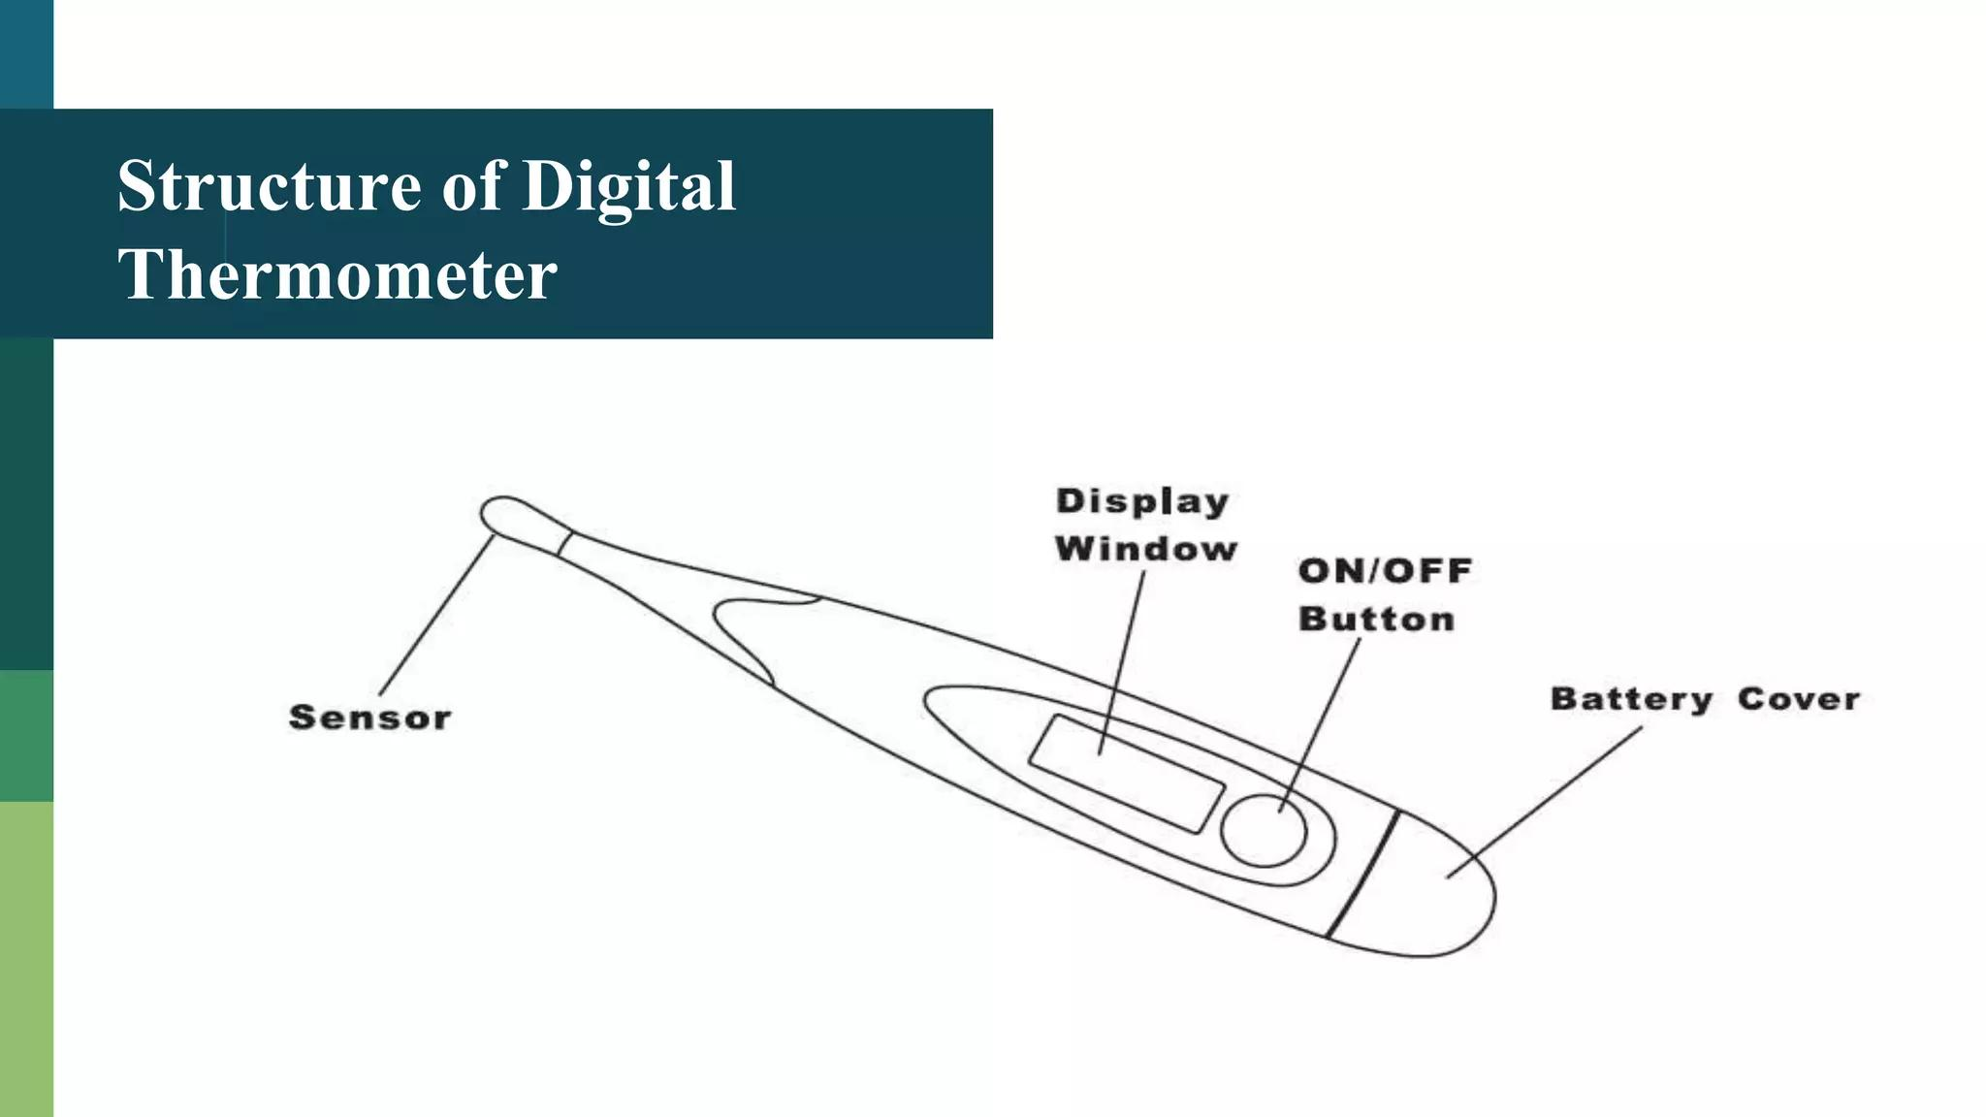
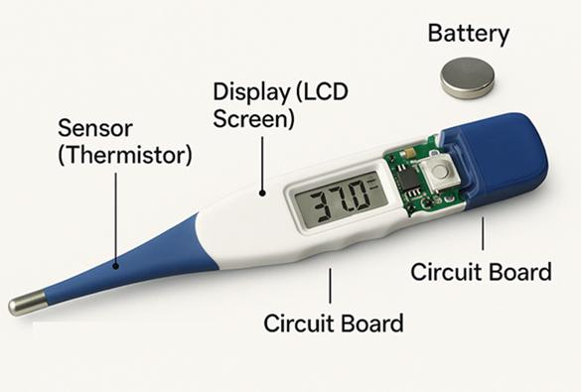
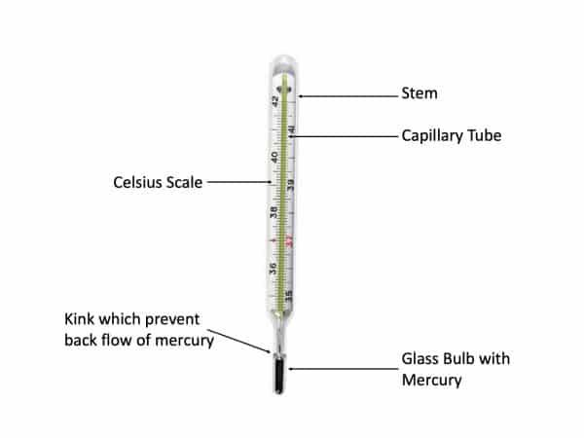
A typical thermometer consists of:
- Temperature sensor
- Measuring element (liquid, sensor, etc.)
- Scale or digital display
- Protective casing
- Probe or sensing tip

Types of Thermometers

1. Mercury Thermometer
# Source: AI Source: Provided by: [Data Path: Persons Table -> ID Column: 1, Name_En Column: Motasem Essam] -> From: [ChatGPT] on [7/17/2026]
Uses mercury sealed inside a glass tube.
Applications
- Laboratories
- Scientific measurements

2. Alcohol Thermometer
# Source: AI Source: Provided by: [Data Path: Persons Table -> ID Column: 1, Name_En Column: Motasem Essam] -> From: [ChatGPT] on [7/17/2026]
Uses colored alcohol instead of mercury.
Applications
- Weather stations
- Educational laboratories
- Low-temperature measurements

3. Digital Thermometer
# Source: AI Source: Provided by: [Data Path: Persons Table -> ID Column: 1, Name_En Column: Motasem Essam] -> From: [ChatGPT] on [7/17/2026]
Uses an electronic temperature sensor.
Applications
- Medical use
- Laboratories
- Industry

4. Infrared Thermometer
# Source: AI Source: Provided by: [Data Path: Persons Table -> ID Column: 1, Name_En Column: Motasem Essam] -> From: [ChatGPT] on [7/17/2026]
Measures temperature without physical contact by detecting infrared radiation.
Applications
- Medical screening
- Electrical inspection
- Food safety
- Industrial maintenance

5. Thermocouple Thermometer
# Source: AI Source: Provided by: [Data Path: Persons Table -> ID Column: 1, Name_En Column: Motasem Essam] -> From: [ChatGPT] on [7/17/2026]
Uses two dissimilar metals to generate a voltage proportional to temperature.
Applications
- Furnaces
- Manufacturing
- Industrial process control

6. RTD (Resistance Temperature Detector)
# Source: AI Source: Provided by: [Data Path: Persons Table -> ID Column: 1, Name_En Column: Motasem Essam] -> From: [ChatGPT] on [7/17/2026]
Uses the predictable change in electrical resistance of a metal (commonly platinum) with temperature.
Applications
- Laboratories
- Industrial automation
- Precision process control

7. Bimetallic Thermometer
# Source: AI Source: Provided by: [Data Path: Persons Table -> ID Column: 1, Name_En Column: Motasem Essam] -> From: [ChatGPT] on [7/17/2026]
Description
Uses a coiled strip made from two different metals that expand at different rates when heated, causing the pointer to move.
Applications
- Ovens
- Boilers
- HVAC systems
- Refrigeration

8. Gas Thermometer
# Source: AI Source: Provided by: [Data Path: Persons Table -> ID Column: 1, Name_En Column: Motasem Essam] -> From: [ChatGPT] on [7/17/2026]
Description
Measures temperature by observing the pressure or volume change of a gas at constant volume or pressure.
Applications
- Scientific research
- Calibration laboratories
- High-accuracy measurements

Measuring Units
# Source: AI Source: Provided by: [Data Path: Persons Table -> ID Column: 1, Name_En Column: Motasem Essam] -> From: [ChatGPT] on [7/17/2026]
Thermometers commonly display:
- Degree Celsius (°C)
- Degree Fahrenheit (°F)
- Kelvin (K)

Measuring Range
# Source: AI Source: Provided by: [Data Path: Persons Table -> ID Column: 1, Name_En Column: Motasem Essam] -> From: [ChatGPT] on [7/17/2026]
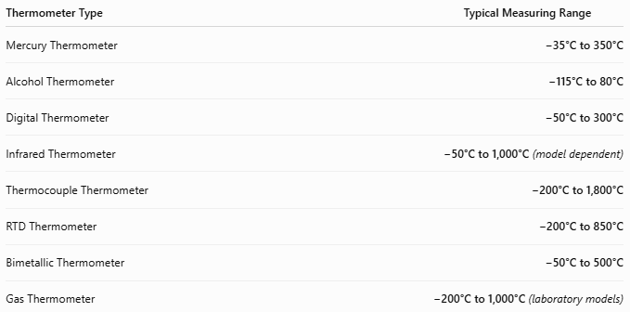
Thermometer Type | Typical Measuring Range
Mercury Thermometer | −35°C to 350°C
Alcohol Thermometer | −115°C to 80°C
Digital Thermometer | −50°C to 300°C
Infrared Thermometer | −50°C to 1,000°C (model dependent)
Thermocouple Thermometer | −200°C to 1,800°C
RTD Thermometer | −200°C to 850°C
Bimetallic Thermometer | −50°C to 500°C
Gas Thermometer | −200°C to 1,000°C (laboratory models)

Resolution
# Source: AI Source: Provided by: [Data Path: Persons Table -> ID Column: 1, Name_En Column: Motasem Essam] -> From: [ChatGPT] on [7/17/2026]
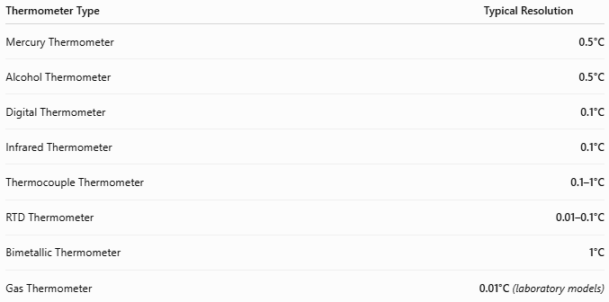
Thermometer Type | Typical Resolution
Mercury Thermometer | 0.5°C
Alcohol Thermometer | 0.5°C
Digital Thermometer | 0.1°C
Infrared Thermometer | 0.1°C
Thermocouple Thermometer | 0.1–1°C
RTD Thermometer | 0.01–0.1°C
Bimetallic Thermometer | 1°C
Gas Thermometer | 0.01°C (laboratory models)

Accuracy
# Source: AI Source: Provided by: [Data Path: Persons Table -> ID Column: 1, Name_En Column: Motasem Essam] -> From: [ChatGPT] on [7/17/2026]
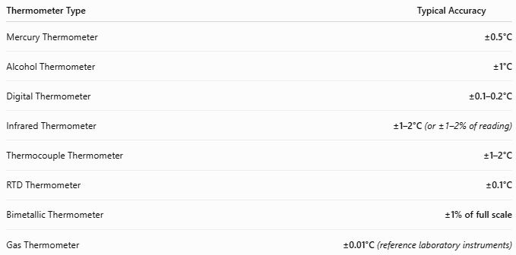
Thermometer Type | Typical Accuracy
Mercury Thermometer | ±0.5°C
Alcohol Thermometer | ±1°C
Digital Thermometer | ±0.1–0.2°C
Infrared Thermometer | ±1–2°C (or ±1–2% of reading)
Thermocouple Thermometer | ±1–2°C
RTD Thermometer | ±0.1°C
Bimetallic Thermometer | ±1% of full scale
Gas Thermometer | ±0.01°C (reference laboratory instruments)
Notes
- RTDs provide the highest accuracy for routine industrial measurements.
- Gas thermometers are among the most accurate and are used as reference instruments in calibration laboratories.
- Infrared thermometers are ideal for non-contact measurements but depend on surface emissivity.
- Accuracy depends on calibration, sensor condition, and operating environment.

How to Use a Thermometer
# Source: AI Source: Provided by: [Data Path: Persons Table -> ID Column: 1, Name_En Column: Motasem Essam] -> From: [ChatGPT] on [7/17/2026]
- Select the appropriate thermometer.
- Place the sensor in contact with the object (or aim an infrared thermometer).
- Wait for the reading to stabilize.
- Read the temperature.
- Clean and store the instrument properly.

Applications
# Source: AI Source: Provided by: [Data Path: Persons Table -> ID Column: 1, Name_En Column: Motasem Essam] -> From: [ChatGPT] on [7/17/2026]
Thermometers are used in:
- Hospitals
- Laboratories
- Weather stations
- Manufacturing
- Food processing
- HVAC systems
- Power plants
- Chemical industries
- Scientific research

Advantages
# Source: AI Source: Provided by: [Data Path: Persons Table -> ID Column: 1, Name_En Column: Motasem Essam] -> From: [ChatGPT] on [7/17/2026]
A thermometer:
- Provides accurate temperature measurements.
- Is available for contact and non-contact use.
- Covers a wide range of temperatures.
- Is available in portable and industrial designs.

Limitations
# Source: AI Source: Provided by: [Data Path: Persons Table -> ID Column: 1, Name_En Column: Motasem Essam] -> From: [ChatGPT] on [7/17/2026]
A thermometer:
- Some types require physical contact.
- Mercury thermometers contain hazardous material.
- Infrared thermometers measure surface temperature only.
- Electronic models require batteries.

Sources of Error
# Source: AI Source: Provided by: [Data Path: Persons Table -> ID Column: 1, Name_En Column: Motasem Essam] -> From: [ChatGPT] on [7/17/2026]
Instrument Errors
- Calibration drift
- Sensor aging
- Damaged probe

User Errors
- Incorrect probe placement
- Reading before stabilization
- Incorrect infrared aiming

Environmental Errors
- Ambient temperature
- Airflow
- Moisture
- Incorrect emissivity (infrared models)

Comparison with Other Temperature Measuring Instruments
# Source: AI Source: Provided by: [Data Path: Persons Table -> ID Column: 1, Name_En Column: Motasem Essam] -> From: [ChatGPT] on [7/17/2026]
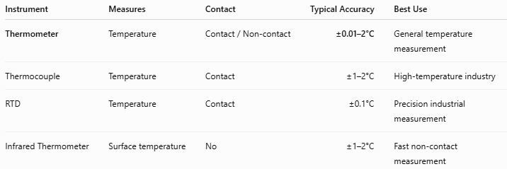
Instrument | Measures | Contact | Typical Accuracy | Best Use
Thermometer | Temperature | Contact / Non-contact | ±0.01–2°C | General temperature measurement
Thermocouple | Temperature | Contact | ±1–2°C | High-temperature industry
RTD | Temperature | Contact | ±0.1°C | Precision industrial measurement
Infrared Thermometer | Surface temperature | No | ±1–2°C | Fast non-contact measurement

Care and Maintenance
# Source: AI Source: Provided by: [Data Path: Persons Table -> ID Column: 1, Name_En Column: Motasem Essam] -> From: [ChatGPT] on [7/17/2026]
To maintain accuracy:
- Keep the sensor clean.
- Store in a protective case.
- Calibrate periodically.
- Replace batteries when needed.
- Avoid dropping the instrument.

Common Mistakes
# Source: AI Source: Provided by: [Data Path: Persons Table -> ID Column: 1, Name_En Column: Motasem Essam] -> From: [ChatGPT] on [7/17/2026]
- Using the wrong thermometer type.
- Reading before stabilization.
- Measuring the wrong surface with an infrared thermometer.
- Ignoring calibration schedules.

Key Points
# Source: AI Source: Provided by: [Data Path: Persons Table -> ID Column: 1, Name_En Column: Motasem Essam] -> From: [ChatGPT] on [7/17/2026]
- A Thermometer measures temperature.
- Common types include:
  - Mercury Thermometer
  - Alcohol Thermometer
  - Digital Thermometer
  - Infrared Thermometer
  - Thermocouple Thermometer
  - RTD Thermometer
  - Bimetallic Thermometer
  - Gas Thermometer
- Common units:
  - °C
  - °F
  - K

Conclusion
# Source: AI Source: Provided by: [Data Path: Persons Table -> ID Column: 1, Name_En Column: Motasem Essam] -> From: [ChatGPT] on [7/17/2026]
A Thermometer is a fundamental measuring instrument used to determine the temperature of solids, liquids, gases, and living organisms. With a wide variety of technologies—including liquid-in-glass, digital, infrared, thermocouple, RTD, bimetallic, and gas thermometers—it serves essential roles in medicine, laboratories, industrial process control, meteorology, food safety, HVAC systems, and scientific research.

